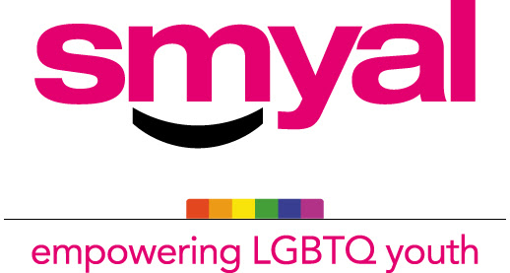

SMYAL Youth Clinical Services
Referral Form

Youth’s name: |  |  | DOB: |  | Age: |  | Pronoun/Pronouns:
Youth’s Cell #: |  |  | Youth’s Email:
Parent/Guardian name: |  |  | Relationship to youth:
Address: |  |  | Ward: | Zip code:
Home phone: |  |  | Parent/Guardian Cell #: | Parent/Guardian Email:
School: |  |  | Grade:
Referral Source: |  |  | Referral Source phone: |  |  | Referral Source email:
Date of Referral:

Relevant issues and concerns:  ☐ Depression  ☐ Anxiety  ☐ Running Away  ☐ Truancy  ☐ Behavioral Problems  ☐ Attention/Hyperactivity  ☐ Abnormal Eating Behaviors  ☐ Trauma symptoms/confirmed findings of physical/sexual abuse or neglect  ☐ Developmental concerns  ☐ Psychosis  ☐Transgender concerns  ☐Identity concerns  ☐ Other (please specify): |  |  | Urgency:  Danger to others  ☐ None ☐Mild ☐Moderate ☐ Severe  Psychotic Symptoms  ☐ None ☐Mild ☐Moderate ☐ Severe  Substance Abuse  ☐ None ☐Mild ☐Moderate ☐ Severe  Non-Suicidal Injury  ☐ None ☐Mild ☐Moderate ☐ Severe  Suicidal Ideation  ☐ None ☐Mild ☐Moderate ☐ Severe  Suicidal Attempt  ☐ None ☐Mild ☐Moderate ☐ Severe  Suicide Plan  ☐ None ☐Mild ☐Moderate ☐ Severe
Functionality:

Problems with Social/friendships/community/interest
☐ None ☐Mild ☐Moderate ☐ Severe

Problems with School
☐ None ☐Mild ☐Moderate ☐ Severe

Problems with Family
☐ None ☐Mild ☐Moderate ☐ Severe

Background/ Brief Social History (reasons for therapy):

Services Offered:

Therapy Services
☐Individual Therapy
☐Family Therapy

Group Therapy
☐ LGBTeens (6-8th grade)
LGBTeens is a LGBTQ group for middle school aged individuals who are exploring gender identity, gender expression, and sexual orientation. LGBTeens focuses on providing a safe space for youth to explore their thoughts and feelings around gender identity, expression, and sexual orientation. This is a closed group held every Thursday @5 pm (virtually).

☐ “Spilling the Tea” Web Group (9-12th grade)
Spilling the Tea is a LGBTQ group for High school aged individuals who are dealing with the pleasures and challenges of life as it relates to exploring gender identity, gender expression, and sexual orientation. Spilling the Tea focuses on giving teens a safe outlet to explore living unapologetically out loud and processing the feelings that come with standing in your truth. This is a closed group held every Thursday @5 pm (virtually).
 | Desired Outcome:(what would you like to accomplish in therapy)

